# UML CLASS DIAGRAM

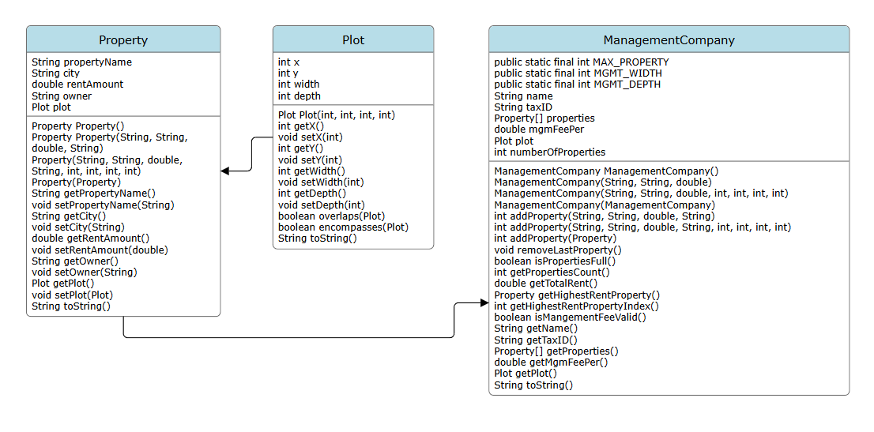

# SCREENSHOTS

## PropertyTestStudent.java

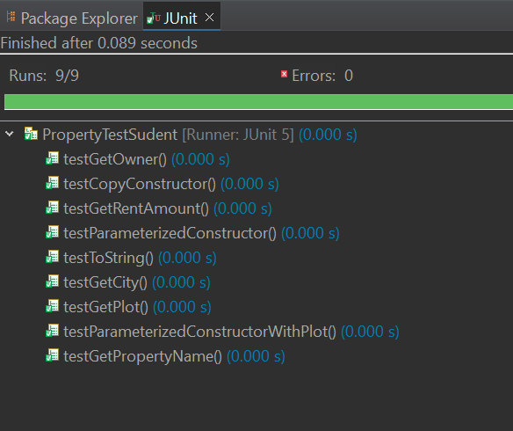

## PlotTestSudent.java

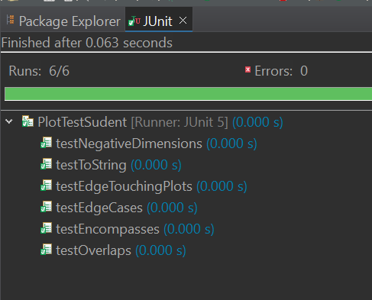

## ManagmentCompanyTestSudent.java

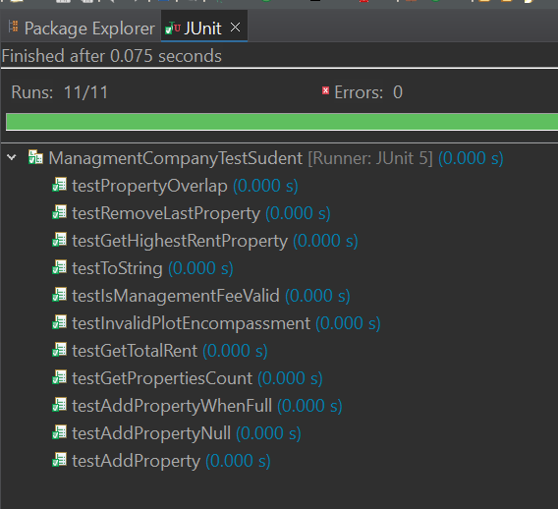

# Screenshot of Runs

## Startup

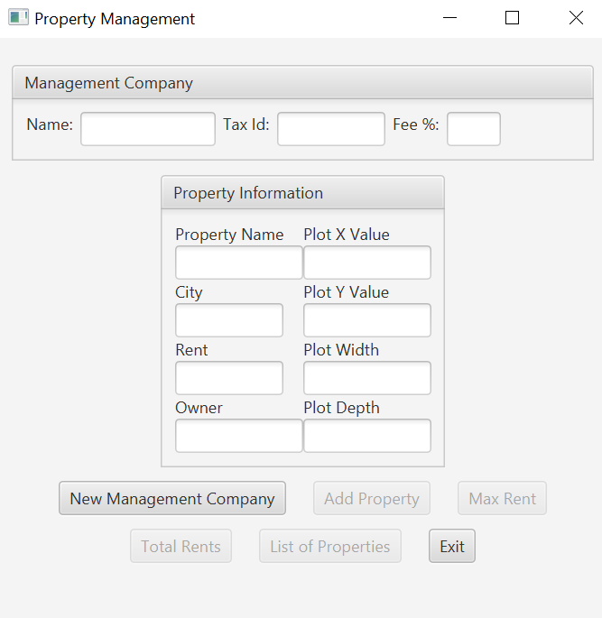

## Add Management Co Info

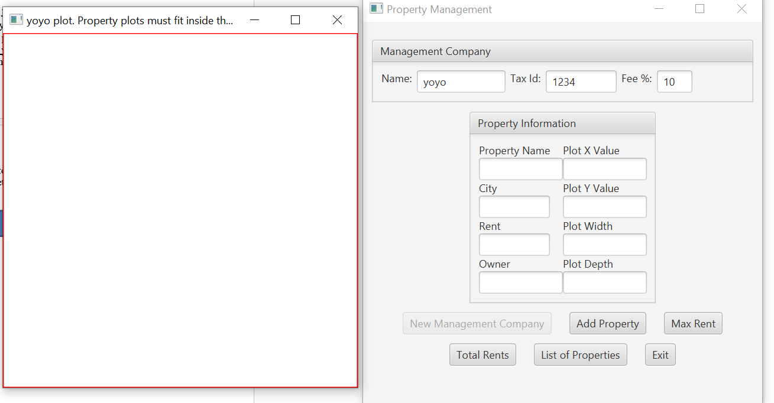

## Add property info plot outline

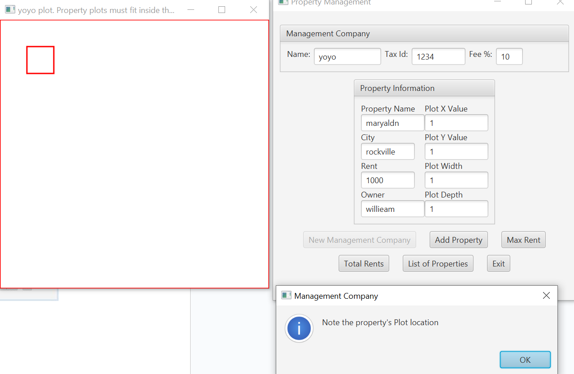

## Add property info successful addition

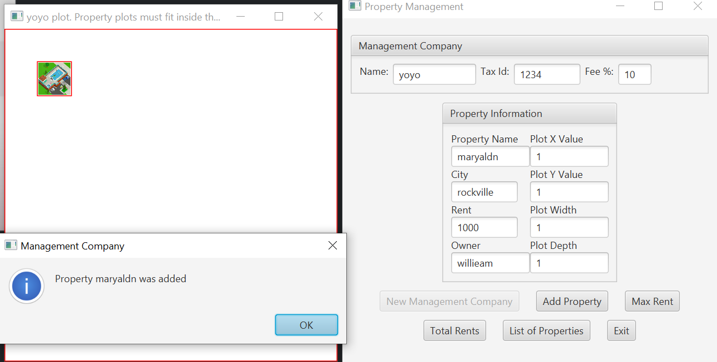

## Add prop info unsuccessful overlap

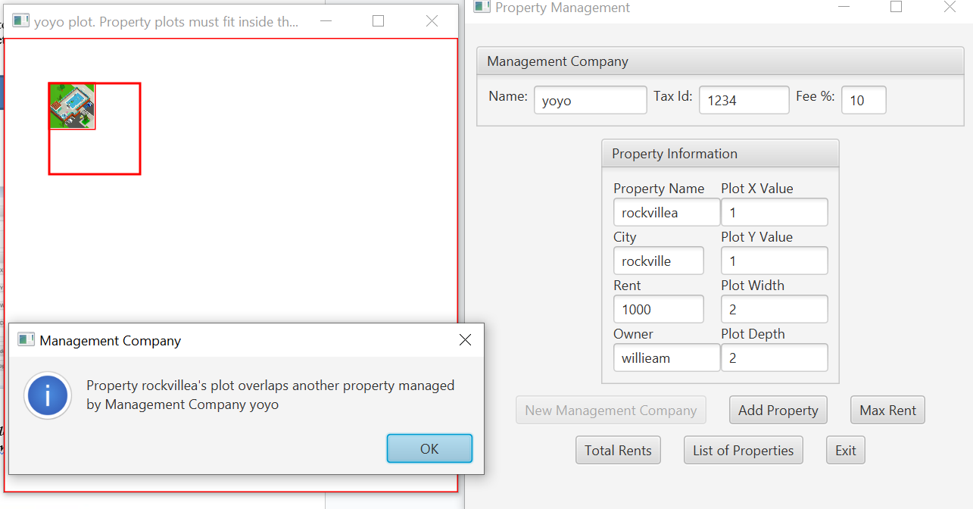

## Add prop info unsuccessful doesn’t encompass

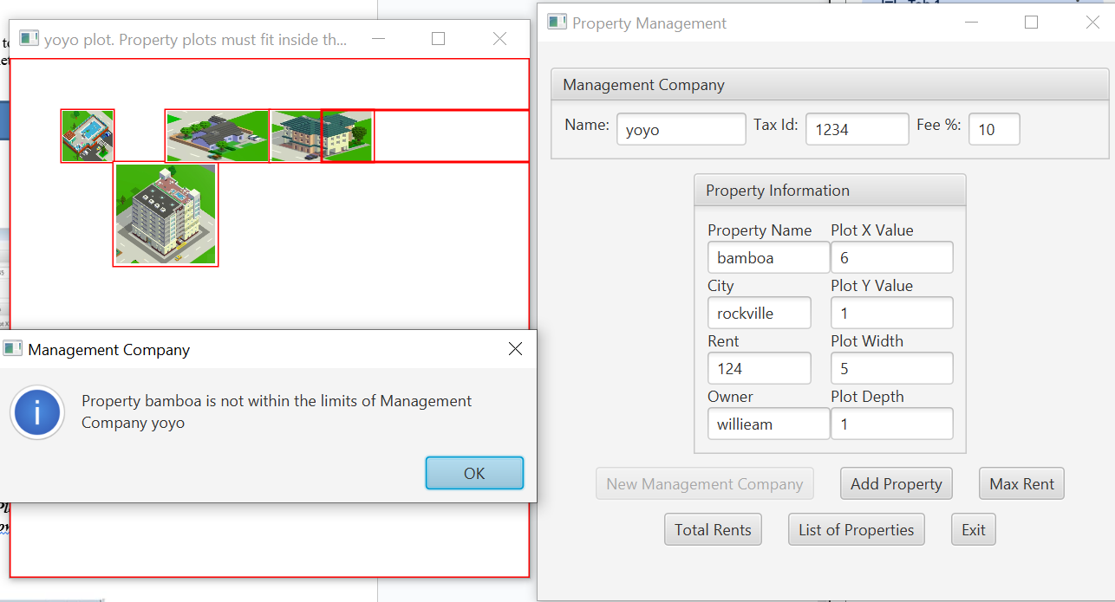

## Add prop info unsuccessful too many properties

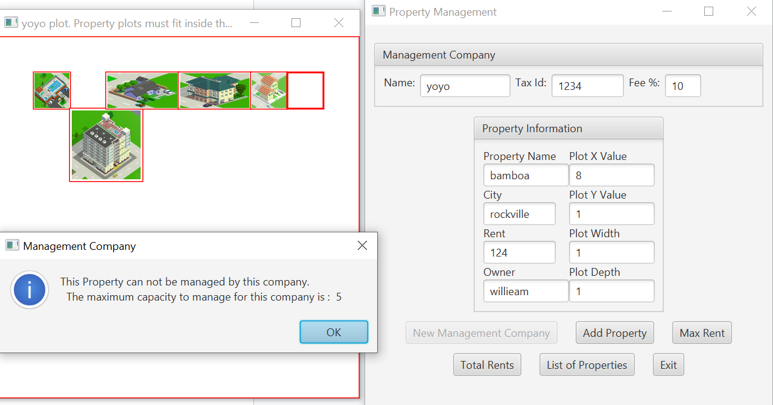

## Result of max rent button

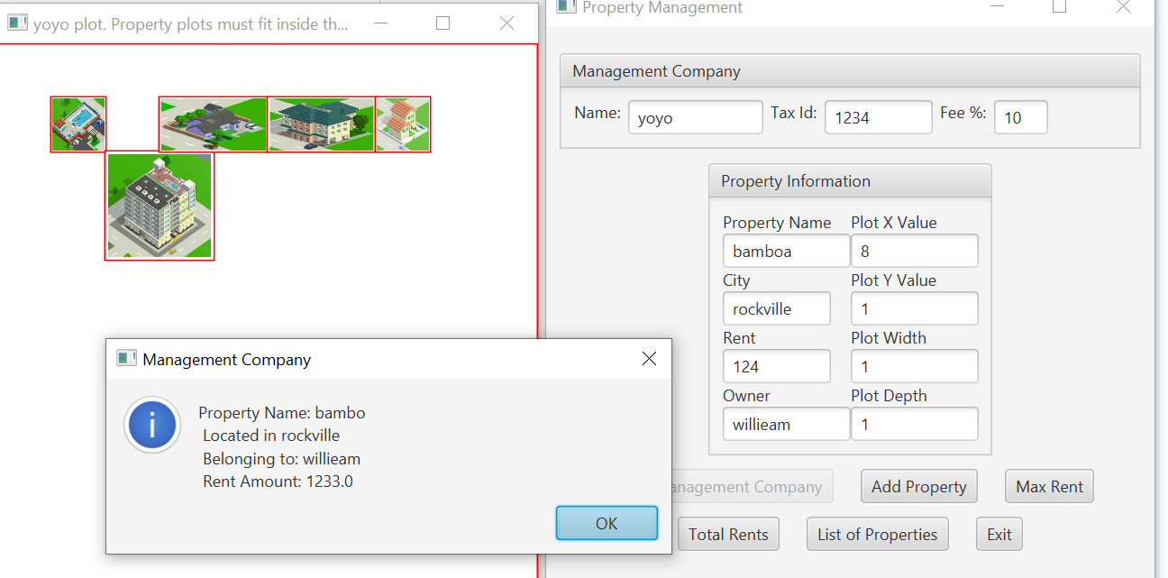

## Result of total rent button

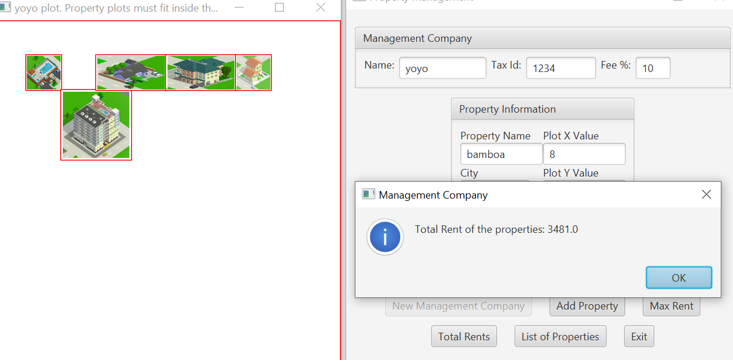

## Result of list of properties button

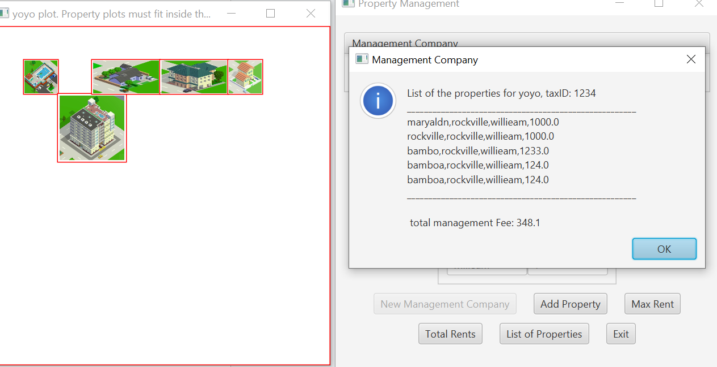

# GITHUB Screenshot

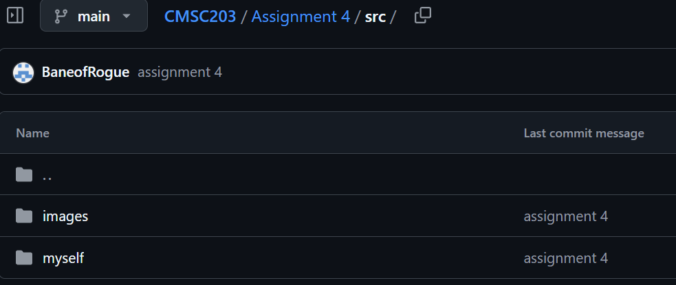

SPECIAL NOTES

MgmCompanyGui.java was edited. Summary:  
“This class is the GUI for the management company. It contains the text fields, buttons, and the plot of the management company. Although I do not like to edit files when suggested not to, I had to edit the code in order to make it work. the function addProp()'s return value was changed from void to Rectangle. More documentation is on the function itself.”

# Lessons Learned

Lessons Learned: Write about your Learning Experience, highlighting your lessons learned and learning experience from working on this project. Provide answers to the questions listed below:

1. **What have you learned?**

I learned how to read other peoples code and work with it, as well as finding and troubleshooting issues.

1. **What did you struggle with?**

I struggled with having the rendered plot boxes to be removed properly, so I had to go on a search to see where the issue was happening.

1. **What would you do differently on your next project?**

I would like to finish it quicker and work on the document more throughout the week.

1. **What parts of this assignment were you successful with, and what parts (if any) were you not successful with?**

I liked working on the test cases, I learned more of how to use them.

1. **Provide any additional resources/links/videos you used to while working on this assignment/project.**

The project files and documentation.